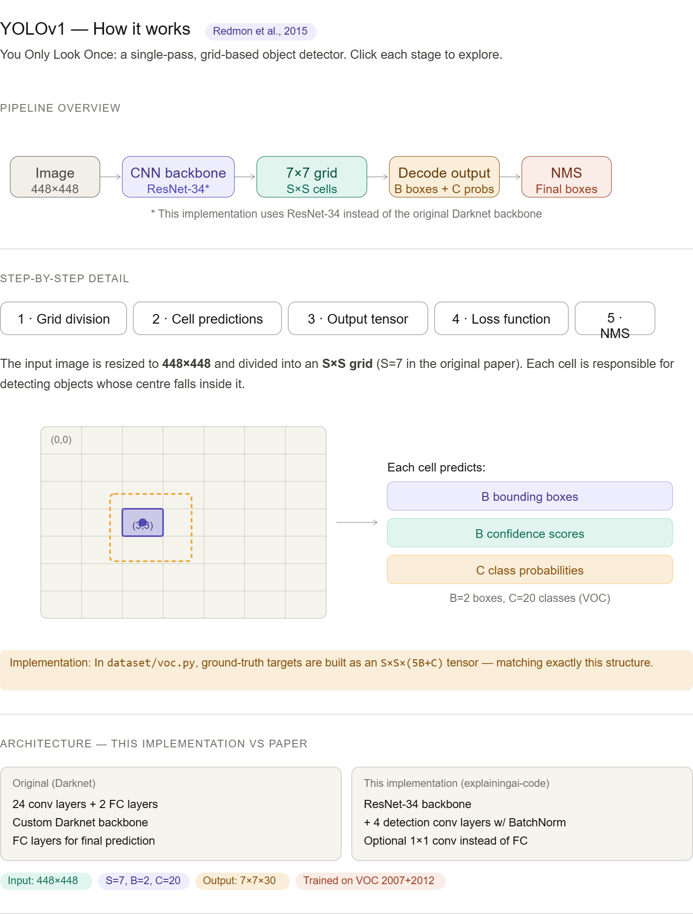
Main idea. The key insight of YOLOv1 is to treat object detection as a single regression problem. Unlike two-stage detectors (i.e. Faster R-CNN) that first propose regions then classify them, YOLO passes the image through the network exactly once and directly predicts boxes and class labels in one shot.
Grid division (Step 1). The image is resized to 448×448 and divided into an S×S grid (S=7, so 49 cells). Each cell is responsible for the detection of any object whose centre falls inside it. This spatial decomposition is what allows YOLO to make spatially distributed predictions in a single forward pass.
Per-cell output (Steps 2–3). Each of the 49 cells predicts B=2 bounding boxes. Each box is encoded as (x, y, w, h, confidence): x and y are offsets from the cell's top-left corner (0–1), while w and h are fractions of the full image. For the new circle-bounded box algorithm, each box is encoded as (x, y, $√r$, confidence): x and y are offsets from the cell’s top left and encode the middle of the circle, while $√r$ is the Additionally each cell predicts C=1 class probability (originally C=20) scores shared across its B boxes as we only need to predict the broccoli class. This gives the S×S×(5×B+C) output tensor, which is 7×7×(5×2+20) originally and 7×7×(4×2+1) with the new bounding circles.
Loss function (Step 4). Training uses a sum-squared error loss with two key design choices: coordinate errors are weighted 5× more heavily than confidence errors (λ_coord=5) to prioritise localisation, and no-object cells are down-weighted by 0.5 (λ_noobj=0.5) because the vast majority of cells contain no object. The square root of w and h is used so that errors in small boxes are penalised proportionally more than errors in large boxes.
NMS (Step 5). At inference time, the 98 raw box predictions (49 cells × 2 boxes) are filtered by confidence threshold, then Non-Maximum Suppression removes duplicate boxes per class by suppressing any box whose IoU with a higher-confidence box exceeds 0.5.
Implementation differences. The explainingai-code repository deviates from the original paper in a few meaningful ways: it uses a ResNet-34 backbone (instead of Darknet), adds BatchNorm to the detection layers, uses sigmoid activation on box coordinates, and optionally replaces the fully-connected prediction head with 1×1 convolutions. These changes together improved mAP from ~52% to ~58% on VOC2007.

